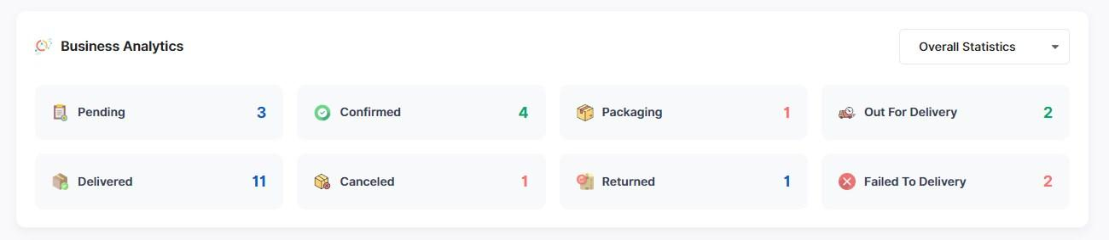
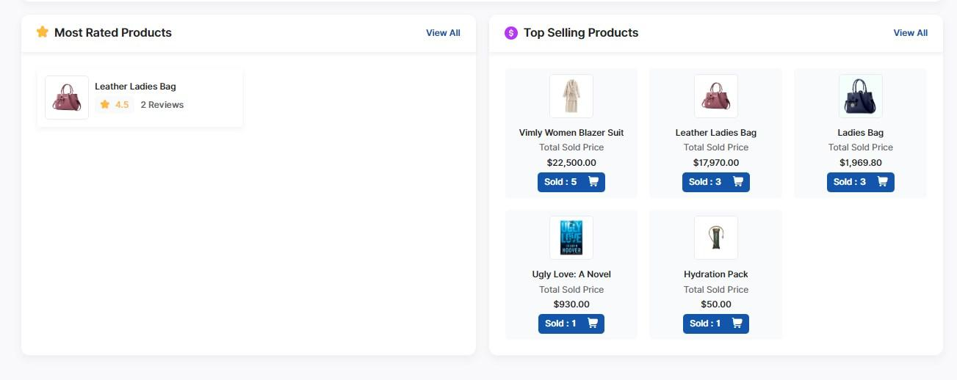
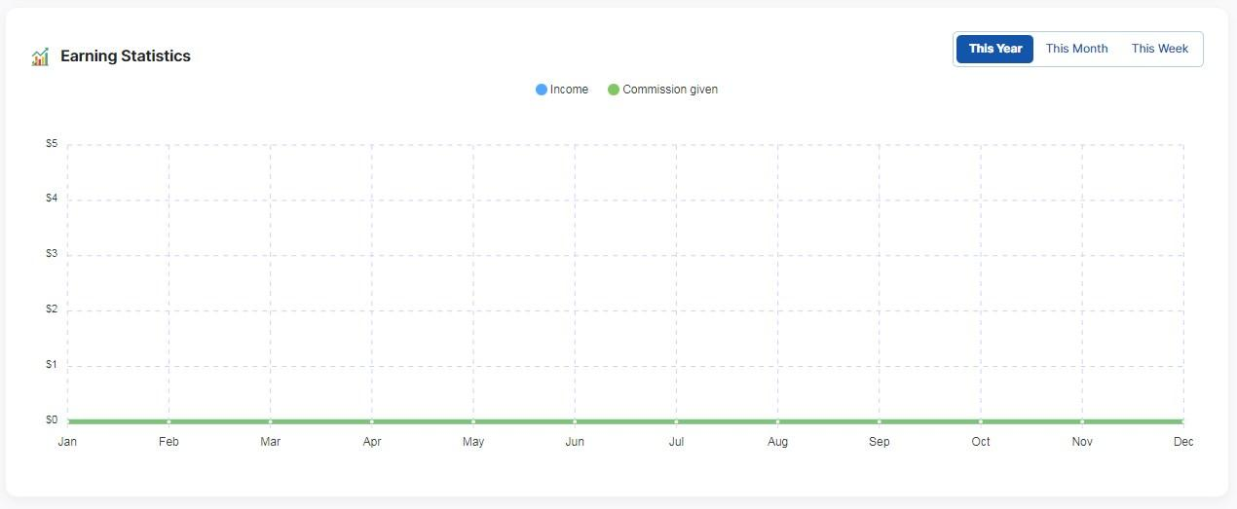
Dashboard Welcome LookFame 1 day

- Show the “All” tab in the Orders-related section of the Admin panel. 2 days for all categories
- The product SKU must be displayed in the Orders section along with the product image.
- There should be an option to download labels for all orders simultaneously, rather than opening each order one by one.
- New Order Notifications.
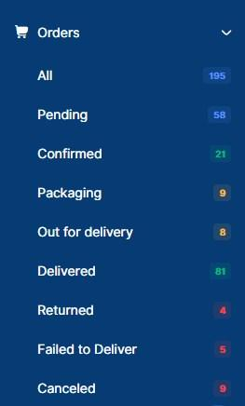

- IF A Customer Cancel the order or return the Product in that condition.
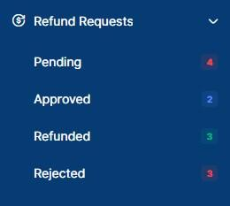

- Product variation/ Attribute Setup in that condition. 1 day for all categories
- Attribute Name as Size(32-34-36) / Pack (1-2-3-4) / Dozen(6-12-24) / Pair(2-4-6)
- Color
- Brand wish product listings.

- Inventory
- Category Stock details.
- Low stock alerts.
- Stock valuation report.
- Product-wise sales vs stock report.

- Add Product and
- Bulk add product.
- Add supporting images 8-10 images at once.

- Rating and reviews.
- Rating and reviews should be completely under our control, where we should have the option to choose which reviews to show and which ones to hide customer-wise not product wise.

- Coupon Setup
- Coupon name e.g. :- Diwali / 15 August / New Year/ winter /summer / Christmas etc.
- Coupon Type e.g. :- Discount On Purchase / First Orders / New customer
- Discount Bearer e.g. :- minimum purchase rs. 1000 get discount 15% off.

- HELP & SUPPORT - WhatsApp and Email
- Inbox ( massages or chat )

- Reports & Analytics (with Filter month/year wise) (Export in Excel ) 1 day
- Transaction Report e.g. (Total Products / Active Products / Inactive Products )
- Total Sales Report e.g. :- (Gross Sales (total sales) / Net Sales (Sales After Cancellations/return)
- Profit report e.g. :- (Gross Profit = Total Revenue – Direct Expenses)
- Product Report e.g. :- (Total Product / Total Product Sale / Total Discount Given / Product Stock / Wish listed Product / Add to cart Product list )
- Order Report e.g. :- (Total Orders / Total Order Amount / Canceled / Ongoing / Completed )
- VAT report e.g.

- Payment Statistics
- Total Payment received
- Digital Payments
- Wallet
- Refunds
- Cash on Delivery (COD)

- User Management 1/half days
- Customers ( Customer list / Customer review / Wallet Coins )
- Subscriber List ( email / Subscription Date)

- Banner Setup - Code base
